**DIATOMACEOUS EARTH**

**HERO**

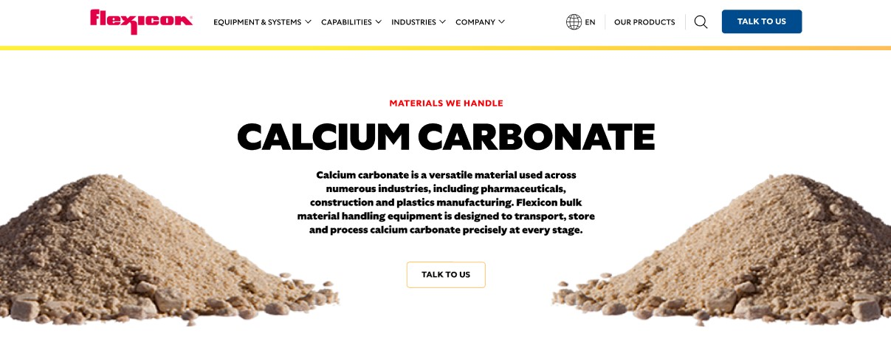

Diatomaceous earth is a fine, silty powder derived from the fossilized remains of diatoms, microscopic sea creatures. Flexicon bulk material handling equipment is engineered to transport, store, and process diatomaceous earth efficiently and safely throughout your operation.

**Button**: Talk To Us

**SHELF #1 - PRODUCT DESCRIPTION**

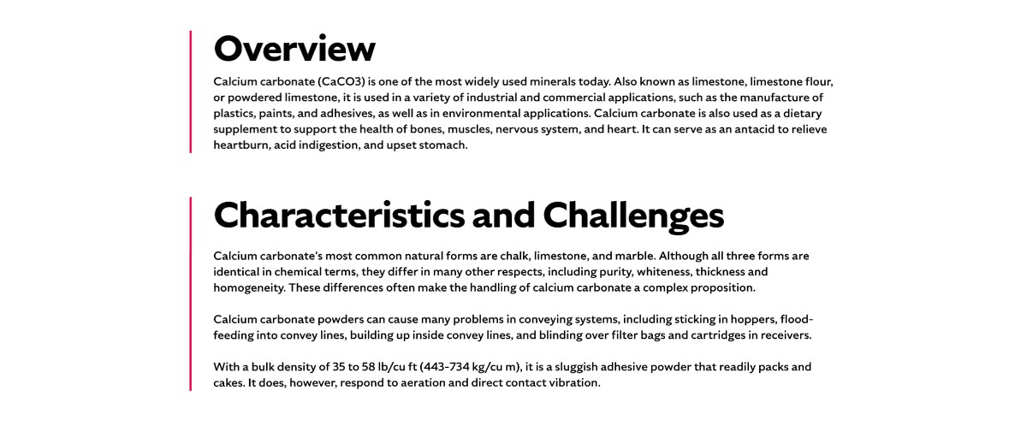

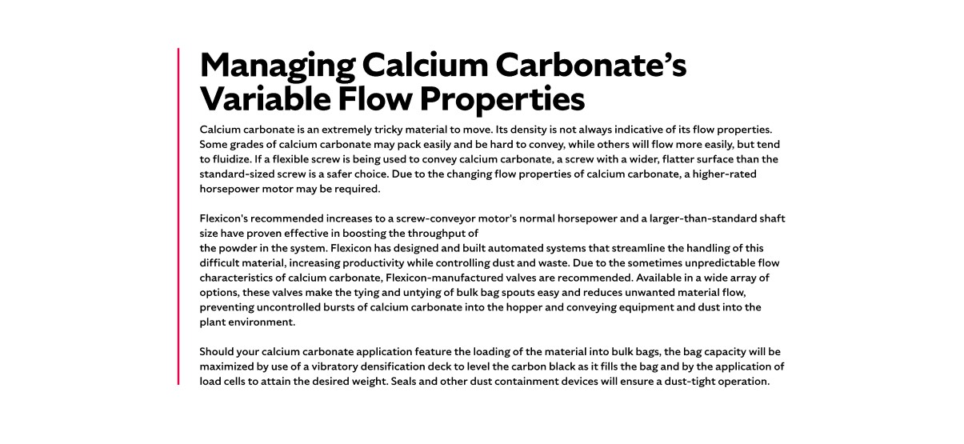

* **Overview**Also known as fossil flour or CELITE®, diatomaceous earth is a versatile, naturally occurring sedimentary rock pulverized into a loose powder. It has diverse commercial and industrial uses ranging from pool filters and toothpaste abrasives to polishing compounds. Historically, diatomaceous earth has been a key ingredient in dynamite, stabilizing nitroglycerin. Food grade diatomaceous earth also finds use as a livestock feed supplement, grain preservative, odor control agent, blood clotting element, and insecticide, with some applications promoting its use as a human health additive.
* **Characteristics and Challenges**Diatomaceous earth is a crystalline silicate with an average bulk density near 16 lb/cu ft. It can appear in multiple physical forms at processing facilities, including packable pellets, abrasive particles, or finely ground powder that may be aeratable or semi-free flowing. These varying forms require specialized handling to maintain consistent material flow.

Due to its dusty nature, diatomaceous earth poses health risks if airborne particles are inhaled, potentially causing respiratory irritation or long-term conditions like silicosis. Handling this material requires careful dust control and engineered conveying solutions designed to address its flow irregularities and abrasive properties.

**SHELF #2 - FLEXICON SOLUTIONS**

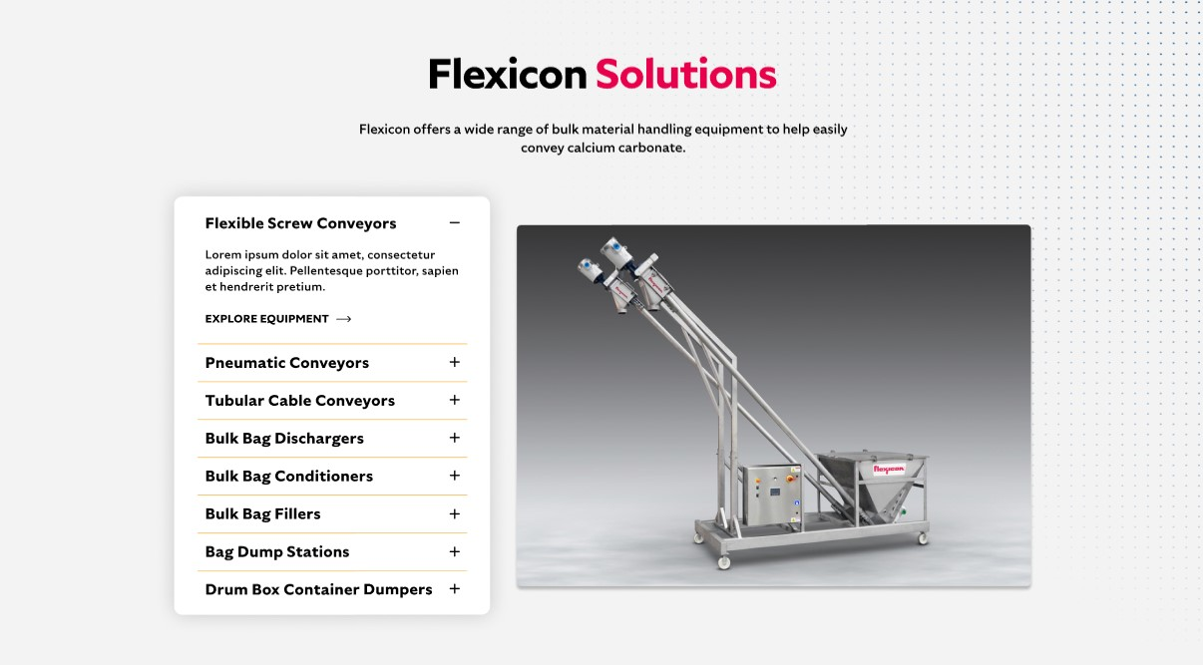

**Flexicon Solutions**

Flexicon offers a wide range of bulk material handling equipment to help easily convey calcium carbonate.

* **Flexible Screw Conveyor**: Convey diatomaceous earth smoothly with screw designs that accommodate powder consistency and incline requirements.
* **Pneumatic Conveyors**: Control dust and maintain steady flow by matching air velocity and system design to the material’s properties.
* **Tubular Cable Conveyors**: Provide enclosed, gentle transport that prevents material degradation and dust emissions.
* **Bulk Bag Dischargers**: Fully empty bulk bags using spring-loaded frames and bag activators to maximize material recovery and promote flow.
* **Bulk Bag Conditioners**: Improve flow by agitating material in bulk bags and breaking up any clumps or bridging.
* **Bulk Bag Fillers**: Optimize bag filling with densification and weight control systems for efficient packaging and dust containment.
* **Bag Dump Stations**: Support manual unloading with dust hoods and filter cartridges to maintain a clean and safe workspace.
* **Drum Box Container Dumpers**: Safely handle various containers with ergonomic dumping equipment that reduces dust and facilitates material transfer.

**SHELF #3: LIFETIME PERFORMANCE GUARANTEE**

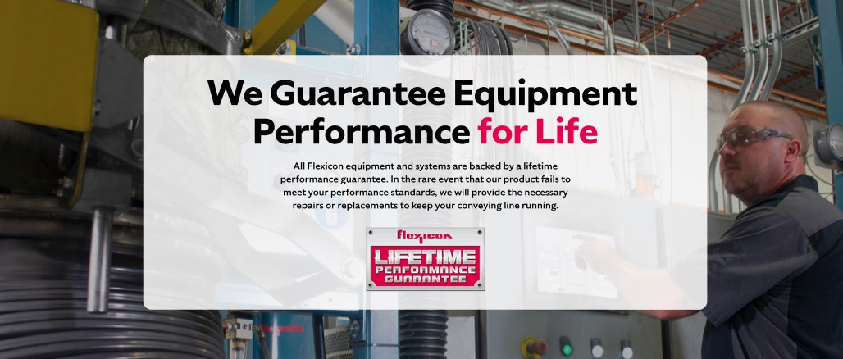

**Lifetime Performance Guarantee**

All Flexicon equipment and systems are backed by a lifetime performance guarantee. In the rare event that our product fails to meet your performance standards, we will provide the necessary repairs or replacements to keep your conveying line running.

**SHELF #4: CASE STUDIES**

